**Science communication 插图版**

As we moved forward with our project, we strove to promote our project and the iGEM competition to the community. We were committed to educating the public about professional biology and leading freshmen in the field of biology to get started.

## Summary

In science communication, we are not only spreader, but also receiver. We try our best to deliver what we have learned to people and students at various stages to acquire biological knowledge and technique. Meanwhile, we received academic help from professors, teachers, and colleges, which made the project more perfect. We also set up a favorable community. Here, we obtain advanced knowledge, and then 'deliver' them to wider population. Without doubt, we play an important role in science communication.

## Communication

### Media Publicity

We promote our project through social media platforms like Wechat. We have accumulated 16 tweets on ZJUT-China's WeChat official accounts, with a cumulative total of 461 followers. Our tweets focused on the introduction of our team and knowledge of science. We also placed our promotion videos and vlogs on other social media platforms and achieved good results.

**The right-down is one of our tweets!**

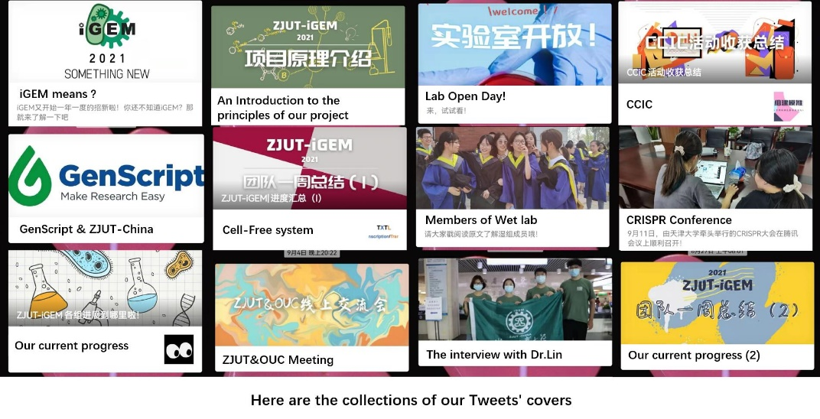

### BIO+ Innovation & Entrepreneurship

We assisted in the implementation of the BIO+ innovation & entrepreneurship, and actively communicated with the teachers of the organizing committee to contact a total of 65 university teams nationwide as the iGEM team to do our part in the implementation of the event.



### Experts

We had some doubts while reviewing the literature and through emails we communicated with several experts. Their replies were of immense help to us. In addition to the online communication, we were honored to have Prof. Jiahuai Han, academician of the Chinese Academy of Sciences and vice president of Xiamen University. Prof. Han solved our problems on gene circuits, evaluated our project and gave us valuable suggestions.

### Project Promotion Meeting

In May and September, we hold the project promotion meeting, hoping to make the projecet have an accurately position and better promotion of the follow-up process. We invited Professor Jingyan Ge and Professor Feng Cheng from the bioengineering college of Zhejiang University of Technology to give valuable suggestions for the project.In the project promotion meeting in May, we reported the composition of team members and the division of tasks in the early stage, introduced the work progress of our project and some problems. The teachers made constructive comments to our project. The promotion meeting in September mainly focused on summarizing the contents of each group during the summer vacation, and discussed the final presentation ideas of the project.

### Lab Meeting

On August 9, we invited team advisor teacher Jingyan Ge and Dongchang Sun to our lab. We were helped to solve several experimental bottkeneck problem problems by the guidance of their professional knowledge.

After the lab meeting, we summarized experience of failure and consulted literature to innovate the experimental ideas, and completed the project targets.

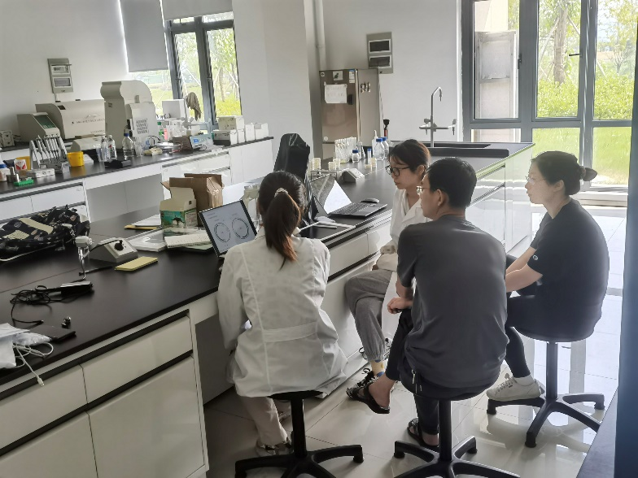

### Acdamitic Seminar

We are not lonely in iGEM. We have carried out close communication with iGEM teams from various universities and held online meetings with XJTLU-IGEM, OUC-China and ASTWS-China. The teams had a energetic discussion on the project and benefited a lot from mutual communication.

**If you want to learn the detail of our seminar, please browse *patnership.***

## Education

### Study Forum

On May 9th, our team participated in ZJUT Study Forum, giving a lecture to all the freshmen on the Pingfeng campus. The lecture included the introduction of iGEM competition, and the 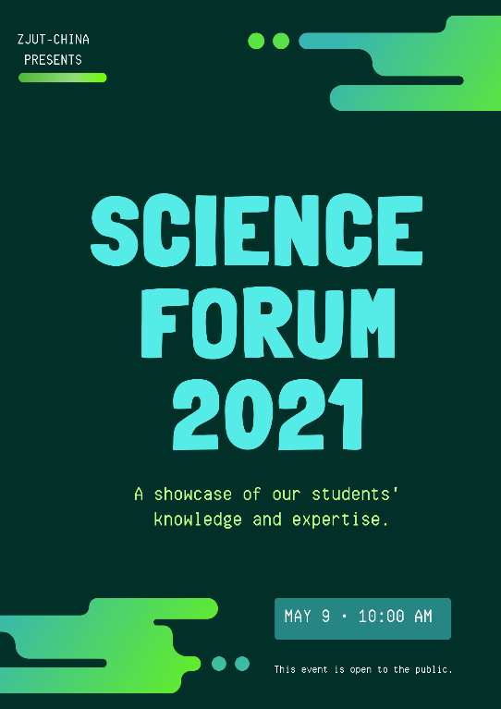introduction of ZJUT-China team's current and previous project mechanism.

### High School Summer Camp

On August 29, we participated in summer camp for high school students to show them the colorful college life and the mechanism of our project. Given that high school students have been taught basic synthetic biology knowledge, we used the knowledge contained in the high school textbook to explain the project mechanism in the PPT, which was well received by the high school students.

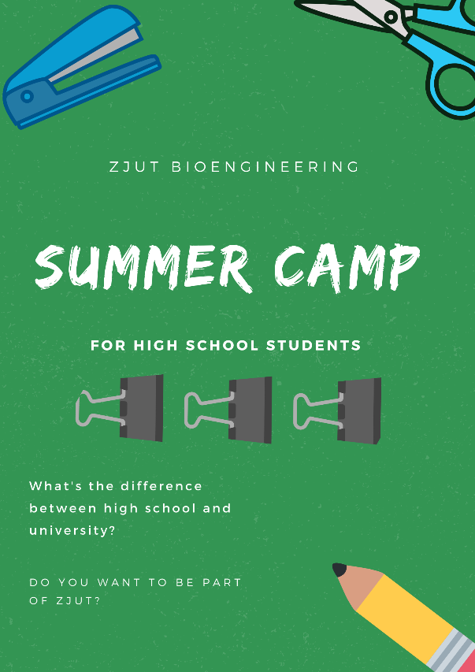

### Lab Open Day

On September 12, we held a lab open day for freshmen. We prepared four separate programs: lab tour, agarose gel electrophoresis, use of pipettes and Culture media preparation. The open day aims to cultivate freshmen's interest in professional knowledge through experiments and instrument explanations. So that they can obtain the joint promotion of theory and practice, and integrate into the study of biology more quickly. Total number of participants reached more than 140 people.

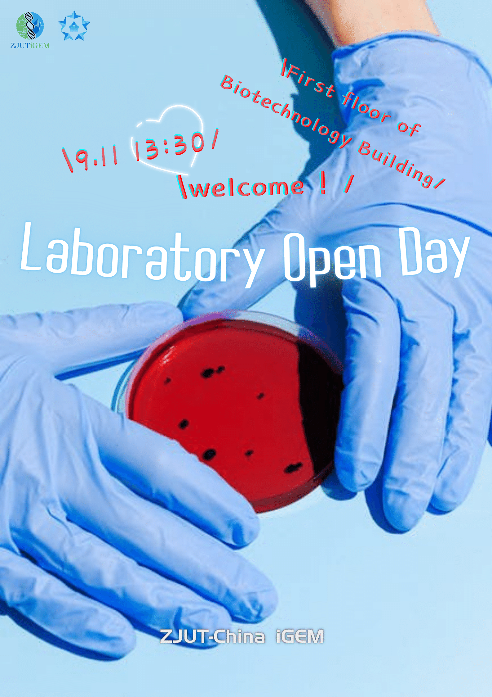

### Qiushan Primary School

On September 28, we prepared a special biology lesson for grade 4 students of Qiushan Primary School. The basic concepts of DNA and variation are vividly explained to children through the combination of PPT and performance. We answered their childlike biology questions and made paper models of Zika virus with them, it gave them a basic idea of the appearance of microorganisms.

